Novel polymer-supported coupling/dehydrating reagents for use in organic synthesis
Kathryn E. Fairfull-Smith (nee Elson),ª Ian D. Jenkins*^{b} and Wendy A. Loughlinª
ª School of Science, Griffith University, Nathan, Brisbane, QLD, 4111, Australia.
^{b} Natural Product Discovery, Griffith University, Nathan, Brisbane, QLD, 4111, Australia.
E-mail: I.Jenkins@griffith.edu.au

SUPPLEMENTARY INFORMATION

Figure 1. Polymer-supported 1,2-bis(diphenylphosphinyl)ethane 8 (gelphase ³¹P NMR spectrum)………………………………………………………………………………..…...2
Figure 2. Polymer-supported 1,1,3,3-tetraphenyl-2-oxa-1,3-phospholanium bis(trifluoromethanesulfonate) 3 (gelphase ³¹P NMR spectrum)…………………………....3
Figure 3. Polymer-supported 1,1,3,3-tetraphenyl-2-oxa-1,3-phospholanium bis(trifluoromethanesulfonate) 3 (gelphase ¹⁹F NMR spectrum)…………………………....4
Figure 4. Stacked gelphase ³¹P NMR spectra of polymer-supported triphenylphosphine oxide with (a) triflic anhydride (0 equiv.); (b) triflic anhydride (0.5 equiv.); (c) triflic anhydride (1.0 equiv.), polymer-supported triphenylphosphine ditriflate 4……………………...………….5
Figure 5. Polymer-supported triphenylphosphine ditriflate 4 (gelphase ¹⁹F NMR spectrum)……...….6
Figure 6. N-Benzyl-N-(4-nitrobenzoyl)-4-nitrobenzamide (¹H NMR spectrum)………………….......7
Figure 7. N-Benzyl-N-(4-nitrobenzoyl)-4-nitrobenzamide (¹³C NMR spectrum)………………..….8
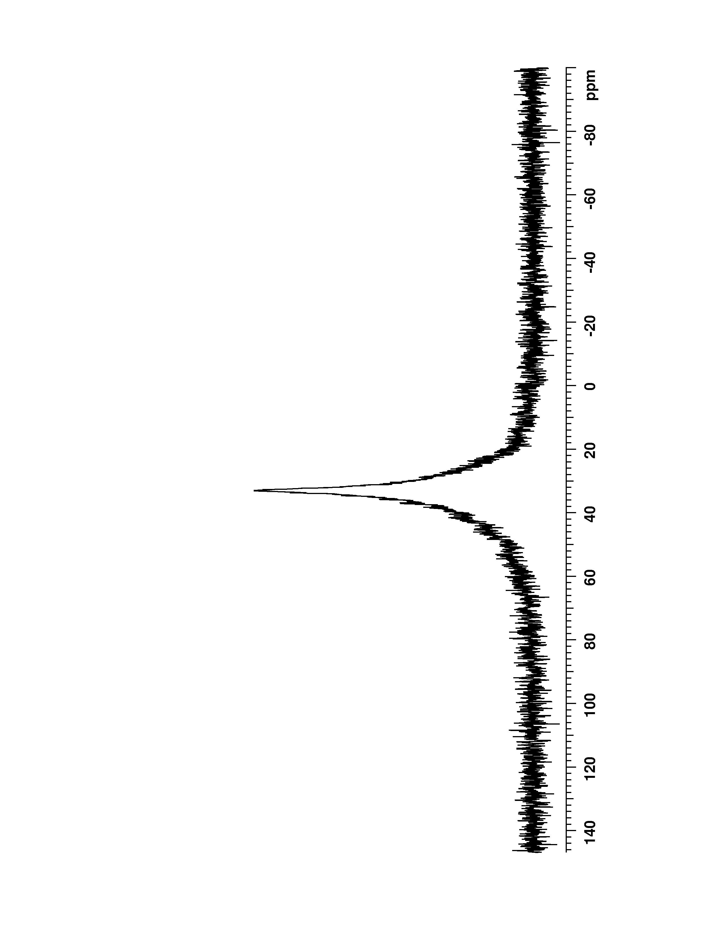
Figure 1. Polymer-supported 1,2-bis(diphenylphosphinyl)ethane 8, ³¹P NMR (162 MHz, CDCl₃, gelphase) spectrum.

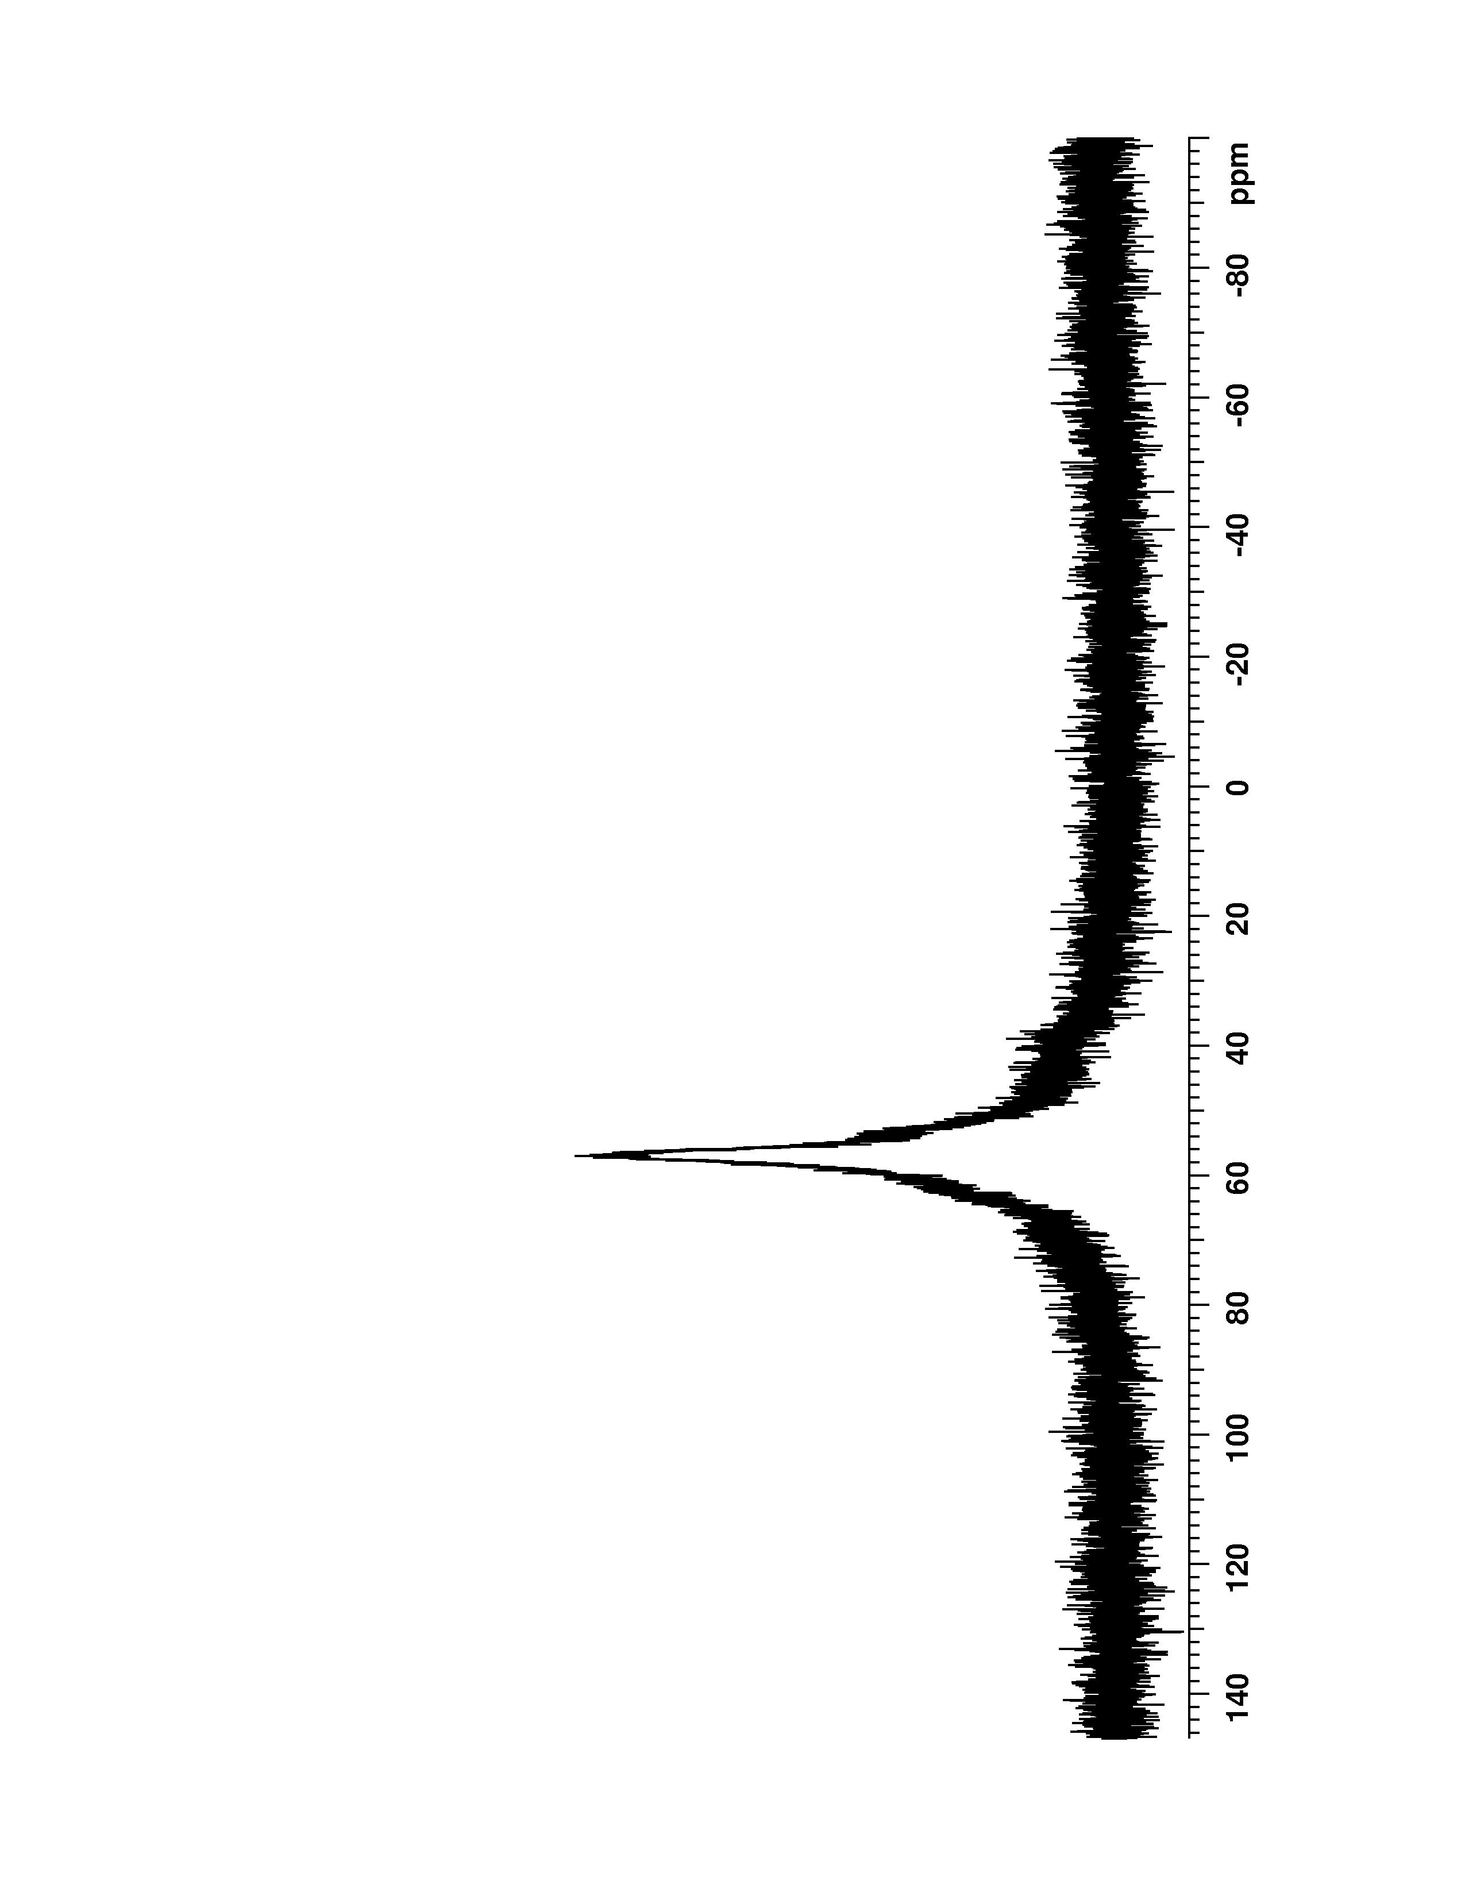
Figure 2. Polymer-supported 1,1,3,3-tetraphenyl-2-oxa-1,3-phospholanium bis trifluoromethanesulfonate 3, ³¹P NMR (162 MHz, CD₂Cl₂, gelphase) spectrum.

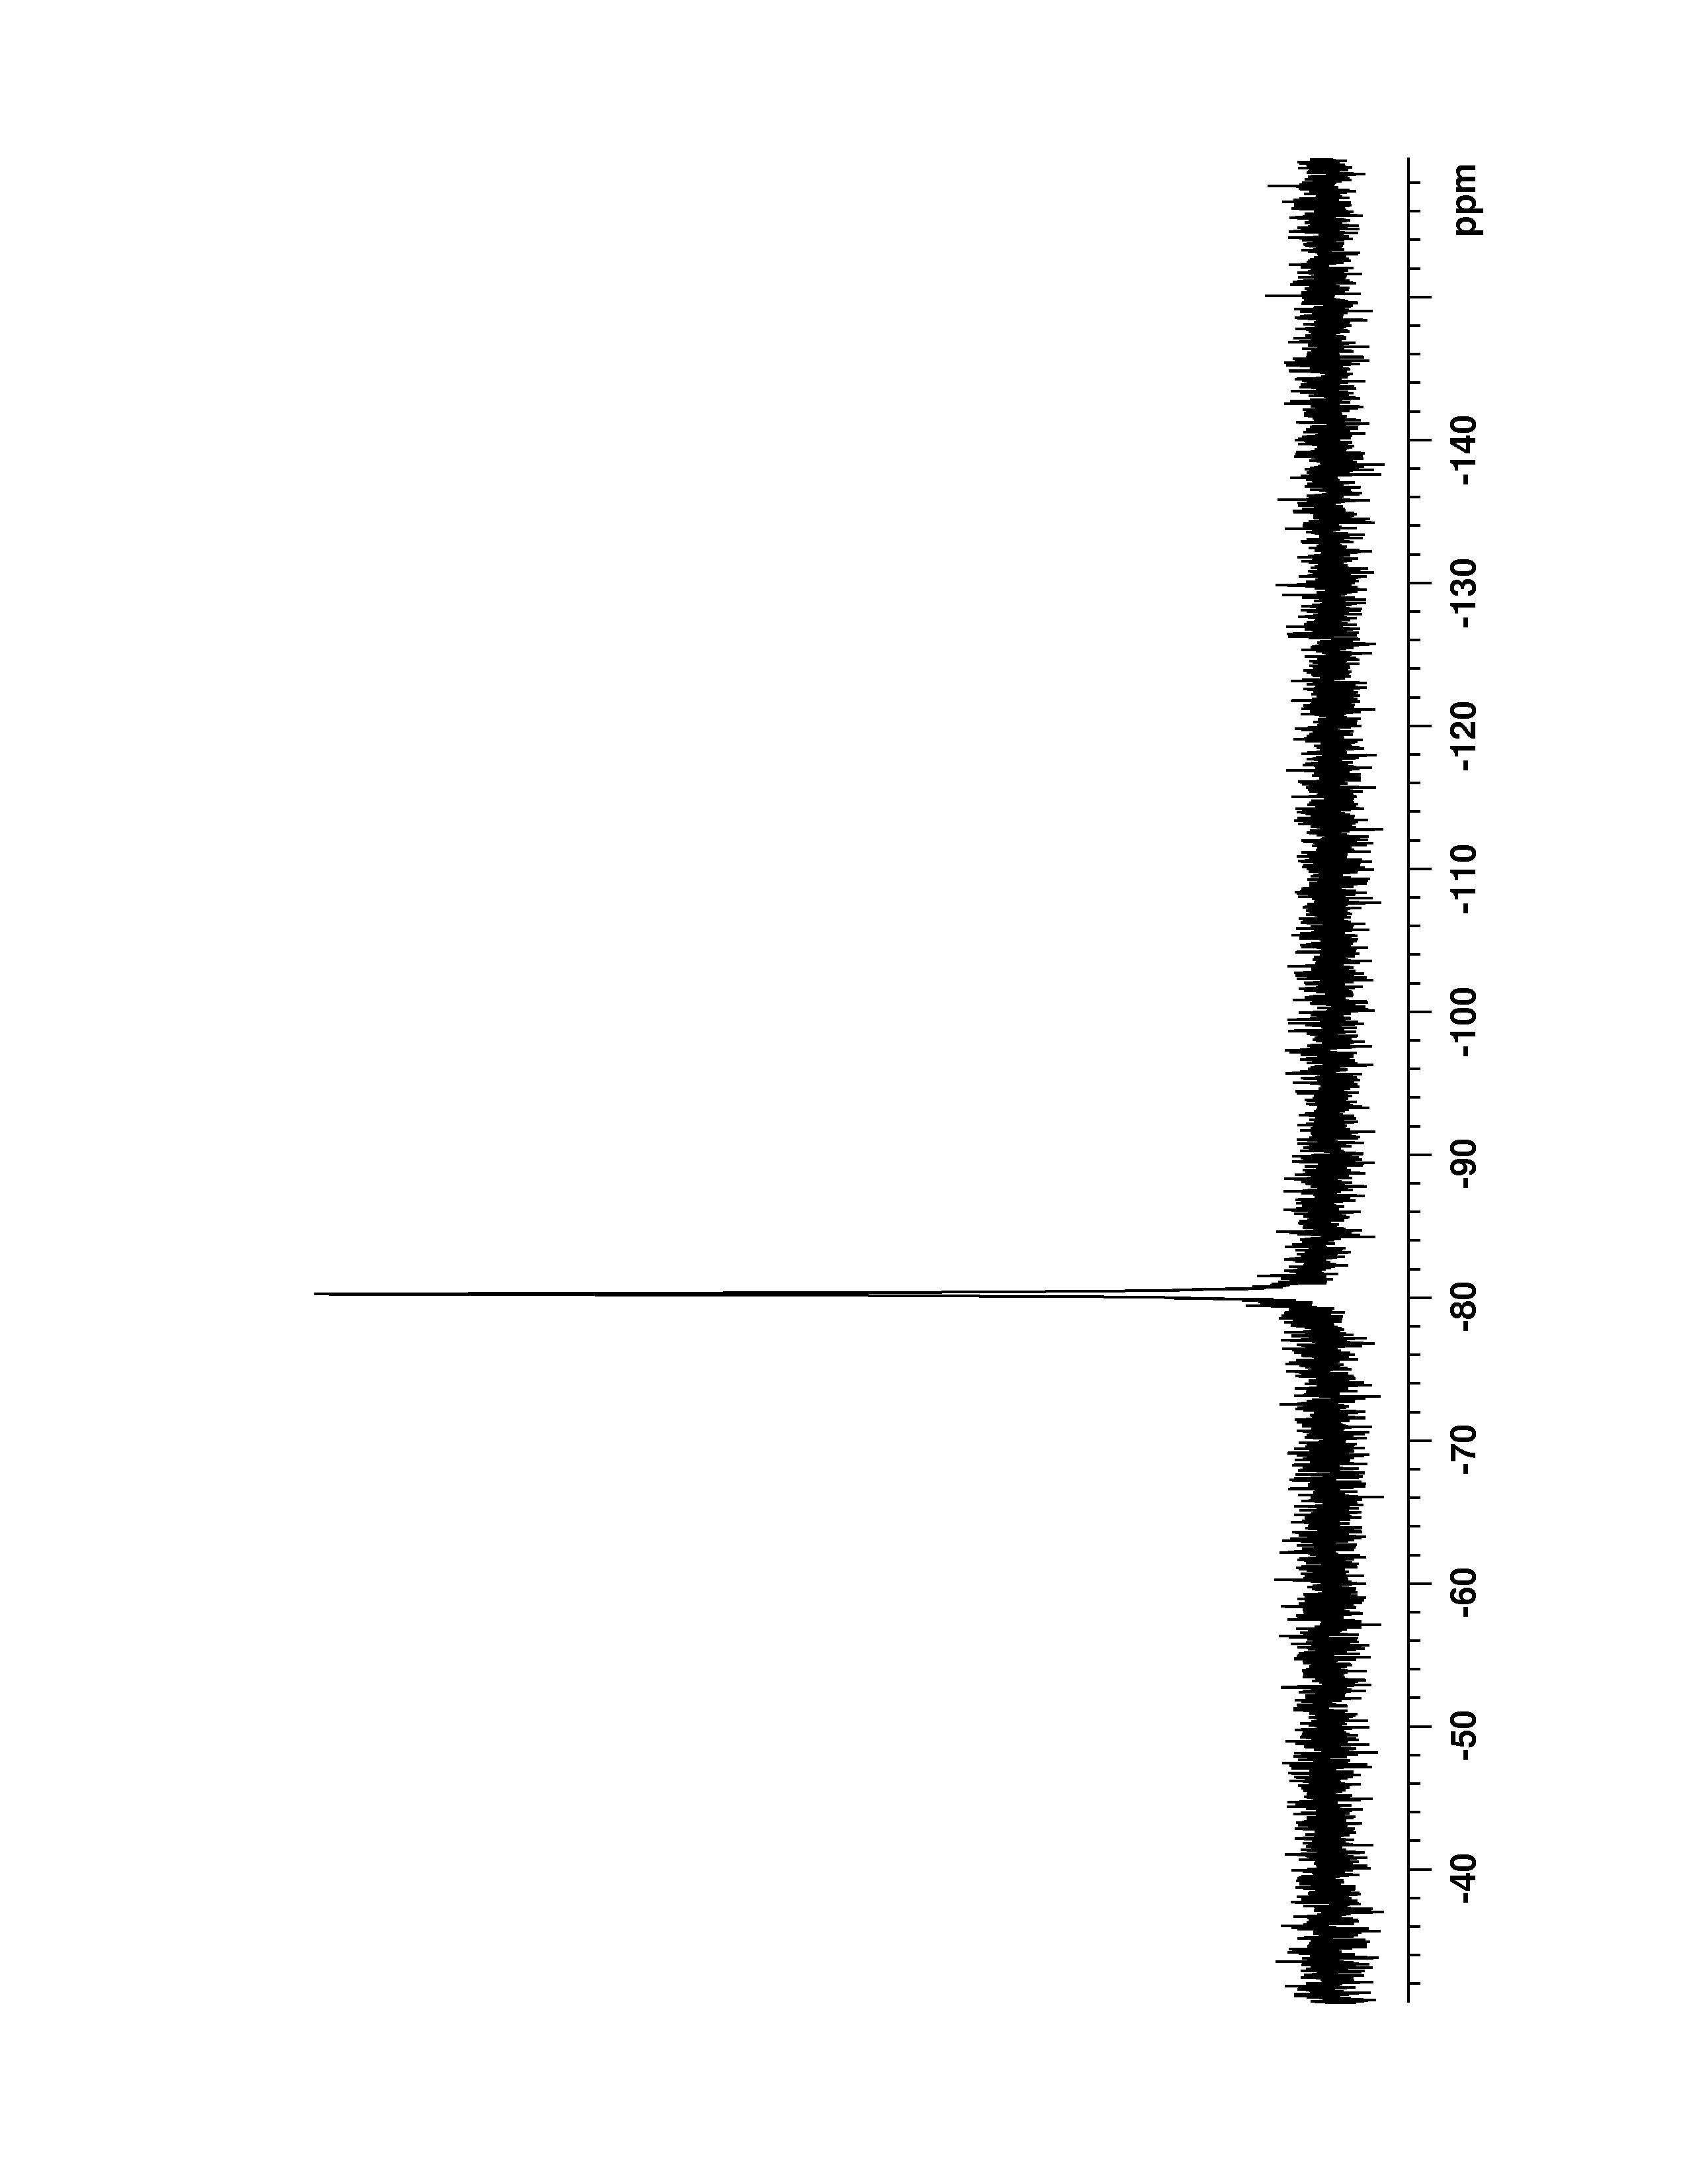
Figure 3. Polymer-supported 1,1,3,3-tetraphenyl-2-oxa-1,3-phospholanium bis trifluoromethanesulfonate 3, ¹⁹F NMR (376 MHz, CD₂Cl₂, gelphase) spectrum.

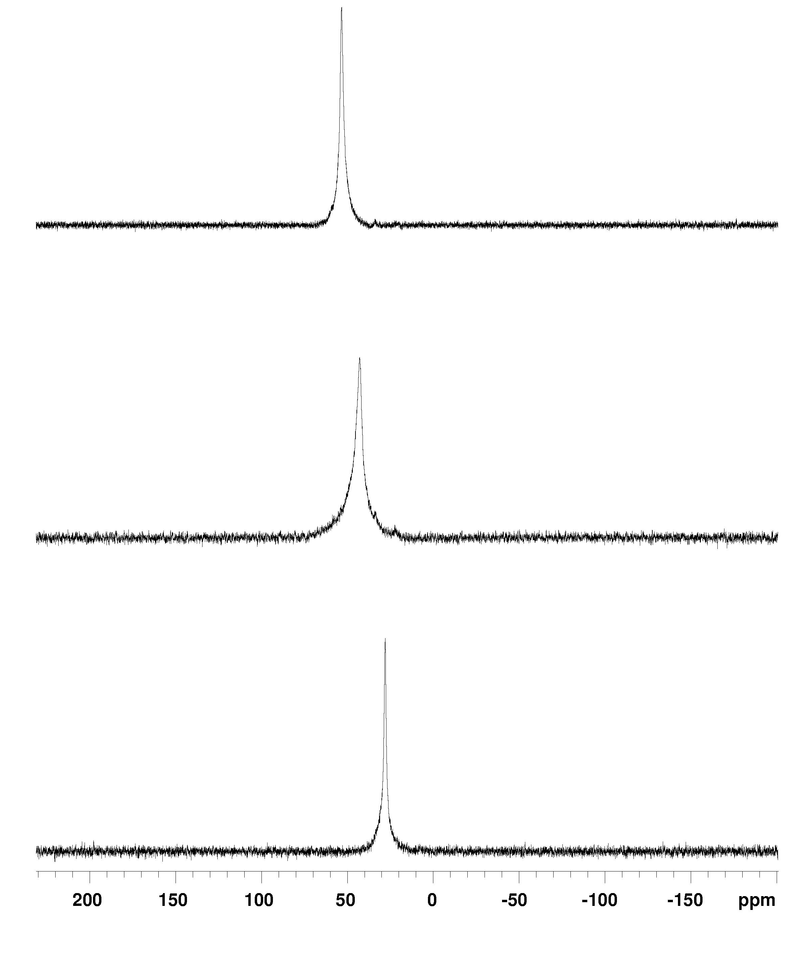
Figure 4. Stacked ³¹P NMR (162 MHz, CD₂Cl₂, gelphase) spectra of polymer-supported triphenylphosphine oxide with (a) triflic anhydride (0 equiv.); (b) triflic anhydride (0.5 equiv.); (c) triflic anhydride (1.0 equiv.), polymer-supported triphenylphosphine ditriflate 4
(a)
(b)
(c)
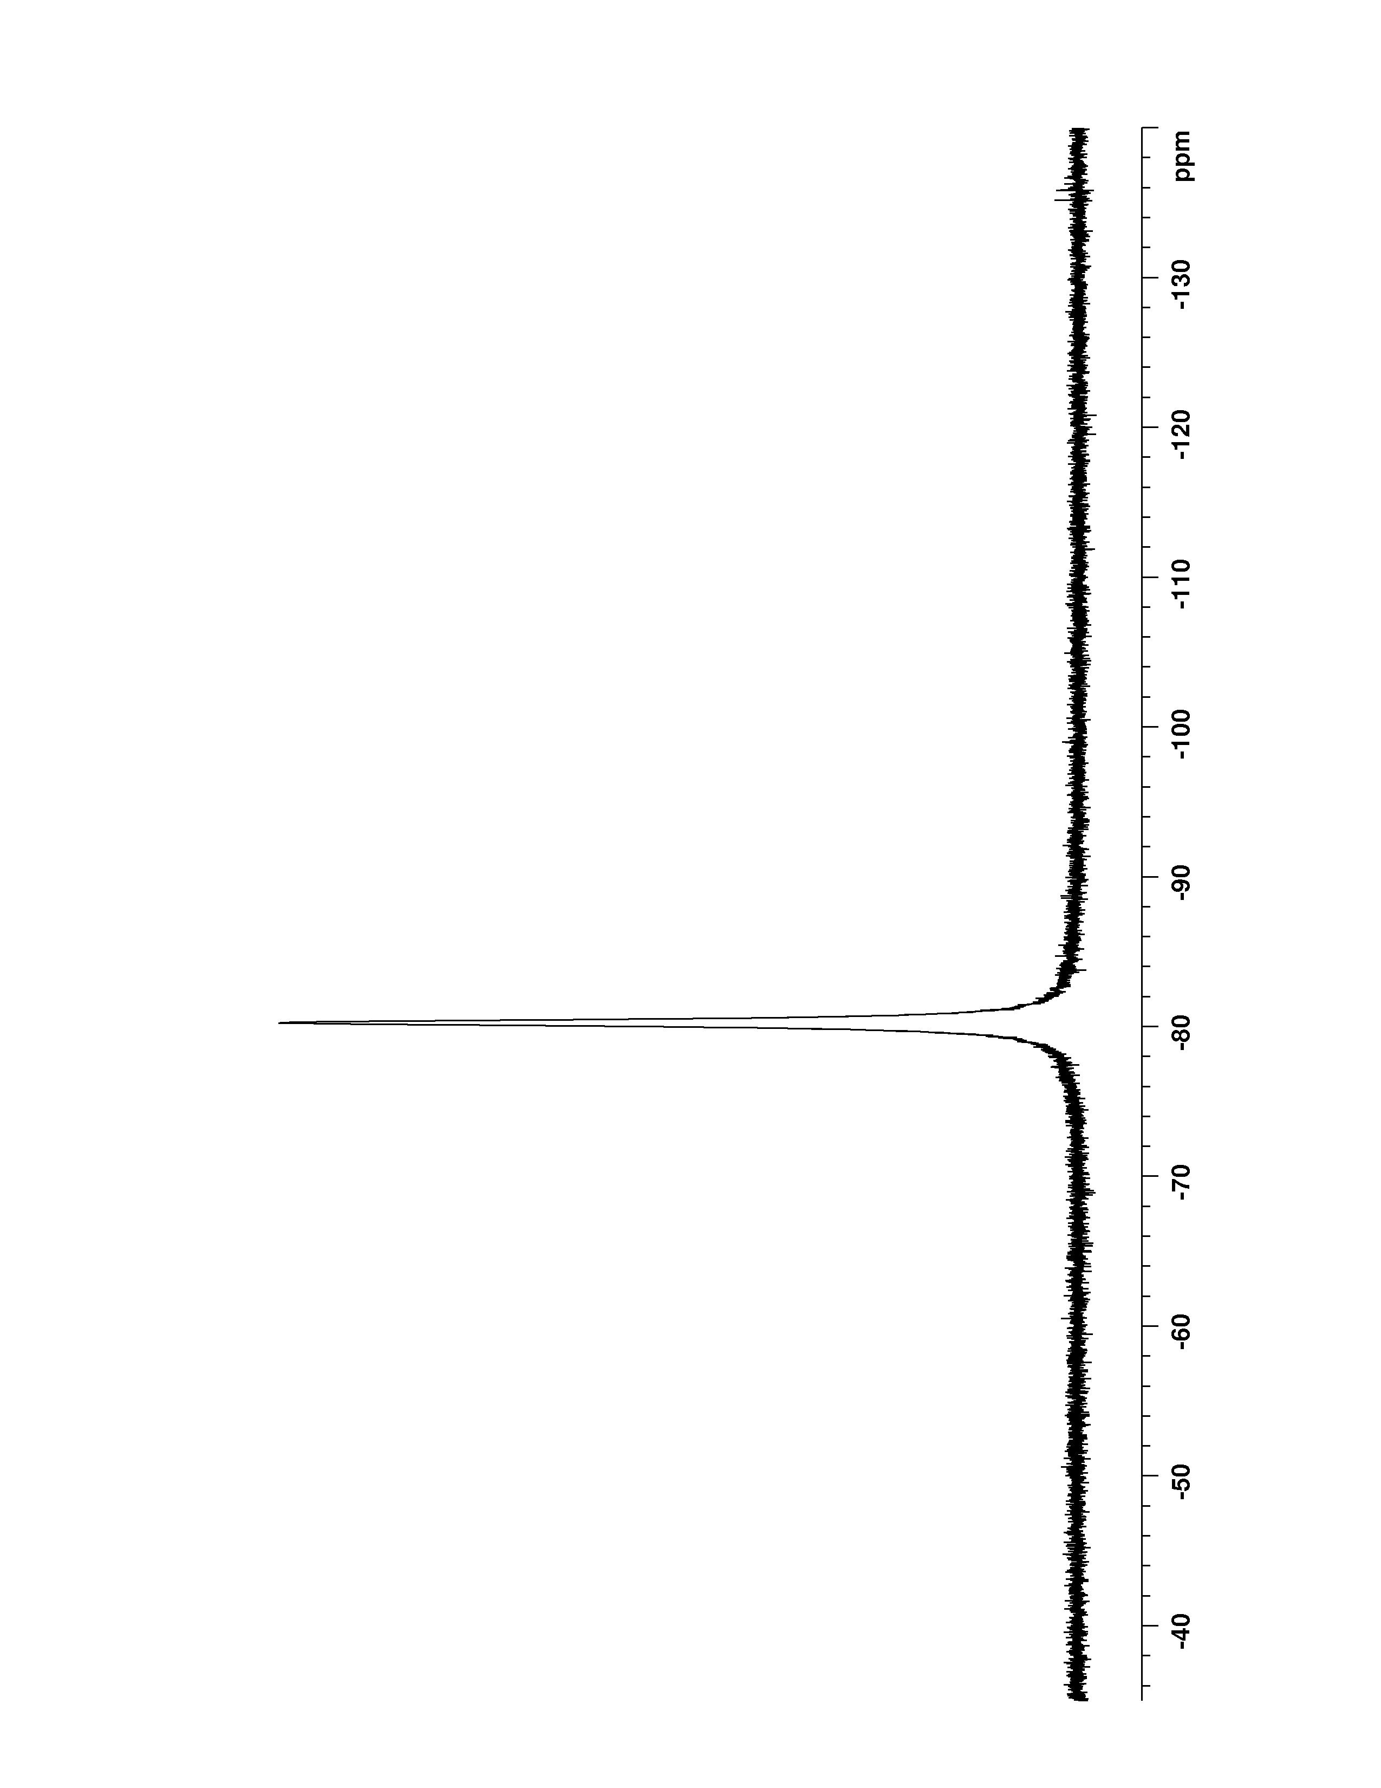
Figure 5. Polymer-supported triphenylphosphine ditriflate 4, ¹⁹F NMR (376 MHz, CD₂Cl₂, gelphase) spectrum.

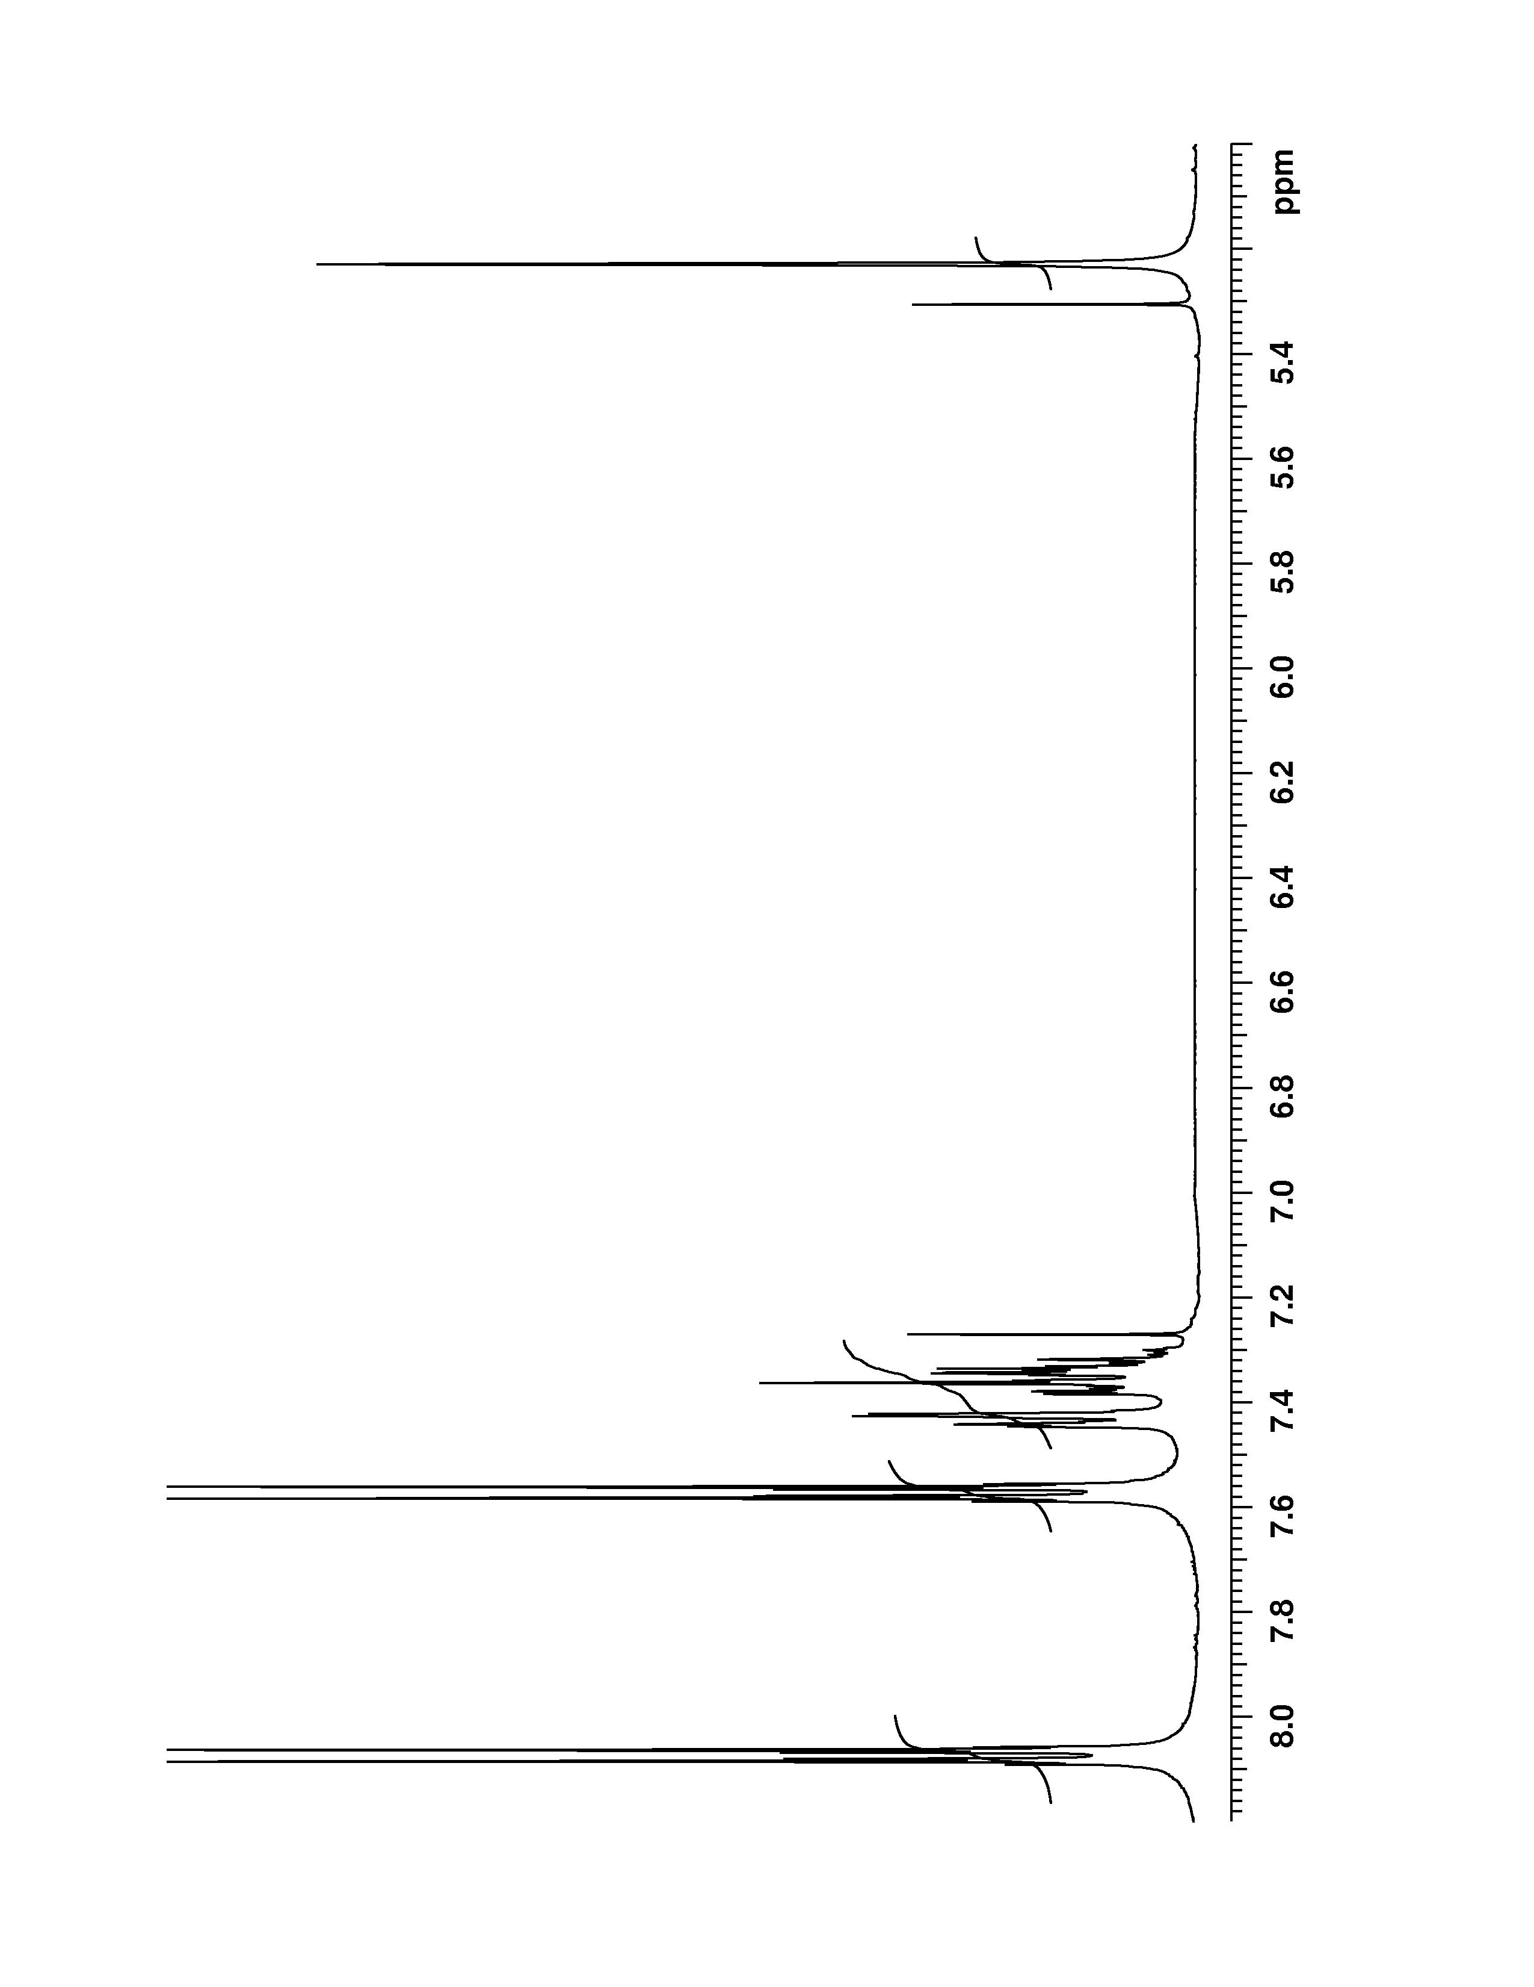
Figure 6. N-Benzyl-N-(4-nitrobenzoyl)-4-nitrobenzamide, ¹H NMR (400 MHz, CDCl₃) spectrum.

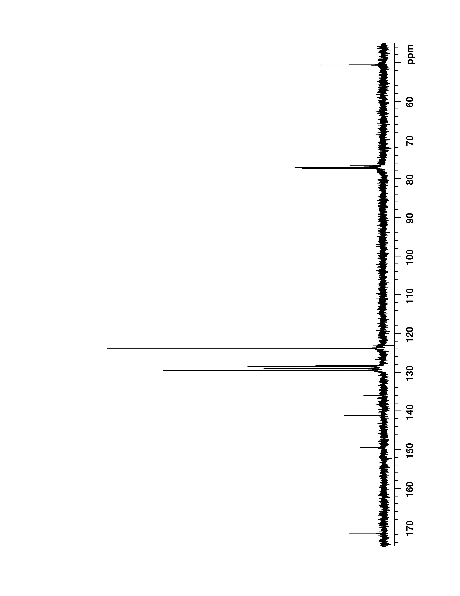
Figure 7. N-Benzyl-N-(4-nitrobenzoyl)-4-nitrobenzamide, ¹³C NMR (100 MHz, CDCl₃) spectrum.

